**EXPERIMENT 1 – CYGWIN INSTALLATION**

**Step 1**: Download Cygwin setup for your machine from Cygwin.com and open the setup file, you will see windows like this. Just click next.

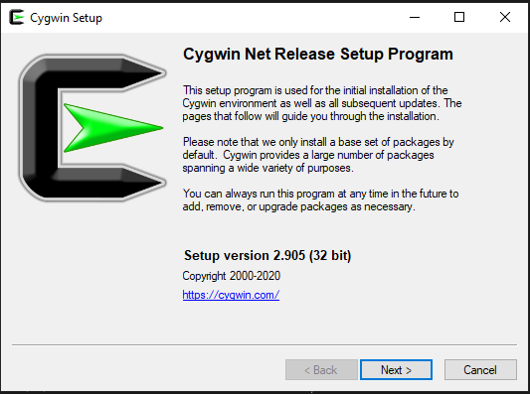

**Step 2**: After clicking next you will see a screen as given below. Select install from internet and click next.

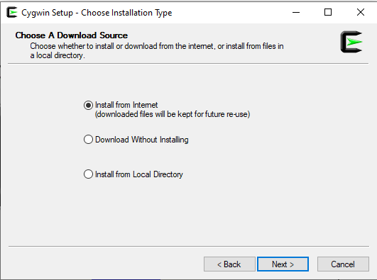

**Step 3**: After that, select your root directory where you want to install the Cygwin. Under that there is another option for install for. For that option select Just me and click on next

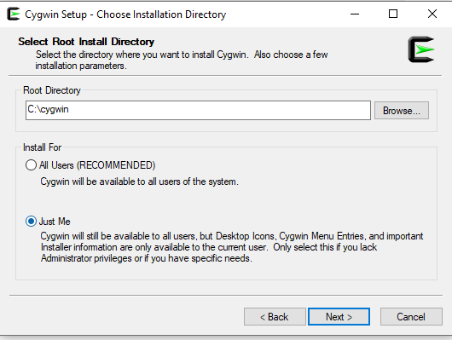

**Step 4:** You will see windows asking for local package directory. You can change it or keep it default depending on your choice. After setting correct directory, click next.

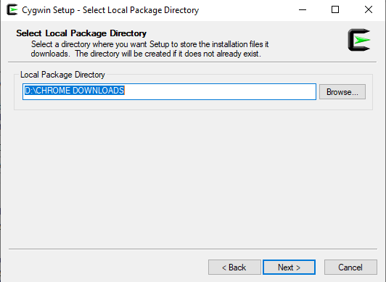

**Step 5**: After that you will see select your internet connection. In my case I keep it as default. After selecting your connection type, click on next to move forward.

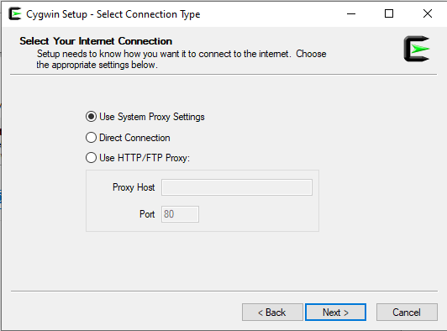

**Step 6**: After clicking next, Cygwin will automatically start connecting from internet. You will see a window like the image below.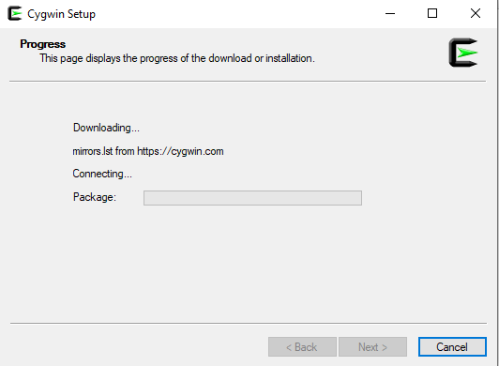

**Step 7**: After that step you will ask to choose a download site. Select the third site and hit on next.

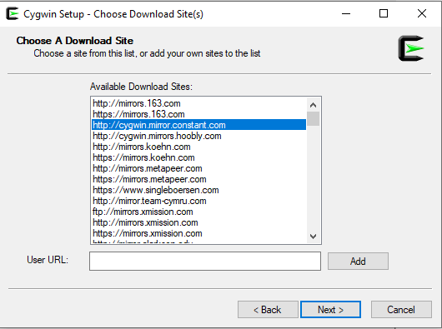

**Step 8**: After clicking next, Cygwin will automatically start downloading. You will see a window like the image below

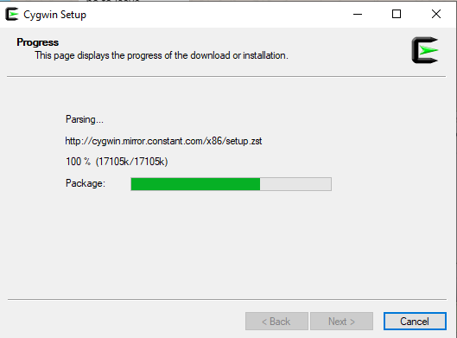

**Step 9**: You will see screen like this, if you want to download some additional package you can search and add them for downloading and installation. If you want only default packages just click next

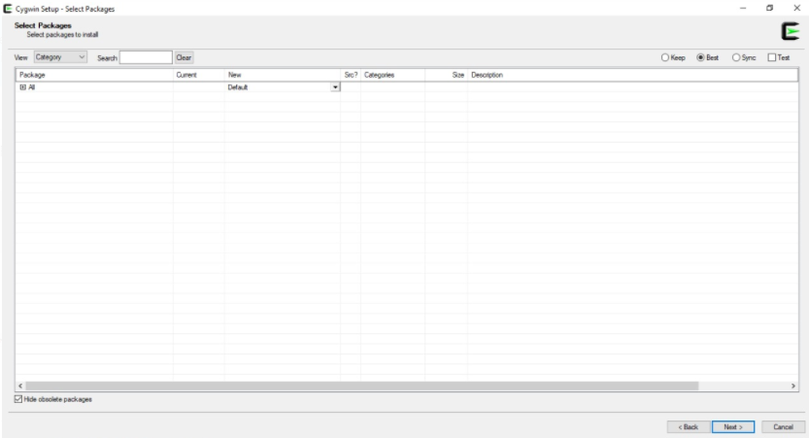

**Step 10**: Here you will see packages you have additionally selected for installation. In my case, I had not selected any packages so it showing no changes. Just click next

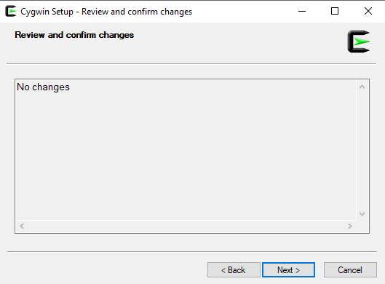

**Step 11**: Installation will begin, it will take around 2 minutes. You can see the progress on the top where it is showing currently 0% - Cygwin setup

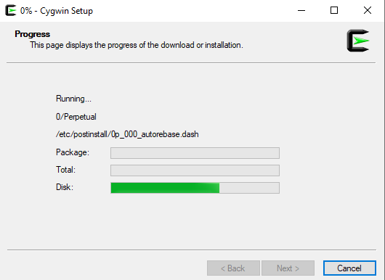

**Step 12**: After the above steps you will see options for icon on desktop and icon to start menu. Its your choice if you want icon on Desktop or start menu or in both places. Just click finish and your installation is complete.